React Notes:

Omer Cohen

Code that will assign the src attribute of an <img/>, based on a random function:

import React from 'react';

import ReactDOM from 'react-dom';

function coinToss() {

// This function will randomly return either 'heads' or 'tails'.

return Math.random() < 0.5 ? 'heads' : 'tails';

}

const pics = {

kitty: 'https://s3.amazonaws.com/codecademy-content/courses/React/react_photo-kitty.jpg',

doggy: 'https://s3.amazonaws.com/codecademy-content/courses/React/react_photo-puppy.jpeg'

};

let img;

// if/else statement begins here:

if (coinToss() == 'head') {

img = <image src={pics.kitty />

} else {

<img src={pics.doggy} /> //**Note:** variables in React must be surrounded by { }

}

Using rendering classes:

import React from 'react';

import ReactDOM from 'react-dom';

class TodaysPlan extends React.Component {

render() {

let task;

if (!apocalypse) {

task = 'learn React.js'

} else {

task = 'run around'

}

return <h1>Today I am going to {task}!</h1>;

}

}

ReactDOM.render(

<TodaysPlan />,

document.getElementById('app')

);

REACT BUTTON CODE EX:

import React from 'react';

import ReactDOM from 'react-dom';

class Button extends React.Component {

scream() {

alert('AAAAAAAAHHH!!!!!');

}

render() {

return <button onClick={this.scream}>AAAAAH!</button>;

}

}

ReactDOM.render(<Button />, document.getElementById('app'));

SIMPLE AUTH PROJECT:

import React from 'react';

import ReactDOM from 'react-dom';

class Contact extends React.Component {

constructor(props) {

super(props);

this.state = {

password: 'Contact',

authorized: false

};

this.authorize = this.authorize.bind(this);

}

authorize(e) {

const password = e.target.querySelector(

'input[type="password"]').value;

const auth = password == this.state.password;

this.setState({

authorized: auth

});

}

render() {

const login = (

<form action="#" onSubmit={this.authorize} >

<input type="password" placeholder="Password"/>

<input type="submit" />

</form>

)

const contactInfo = (

<ul>

<li>

client@example.com

</li>

<li>

555.555.5555

</li>

</ul>

);

return (

<div id="authorization">

<h1>

{ this.state.authorized ? 'Contact' : 'Enter the Password' }

</h1>

{this.state.authorized ? contactInfo : login}

</div>

);

}

}

ReactDOM.render(

<Contact />,

document.getElementById('app')

);

NPM Commands:

New react command: create-react-app <name-of-app>

Installing react:

npm install -g create-react-app

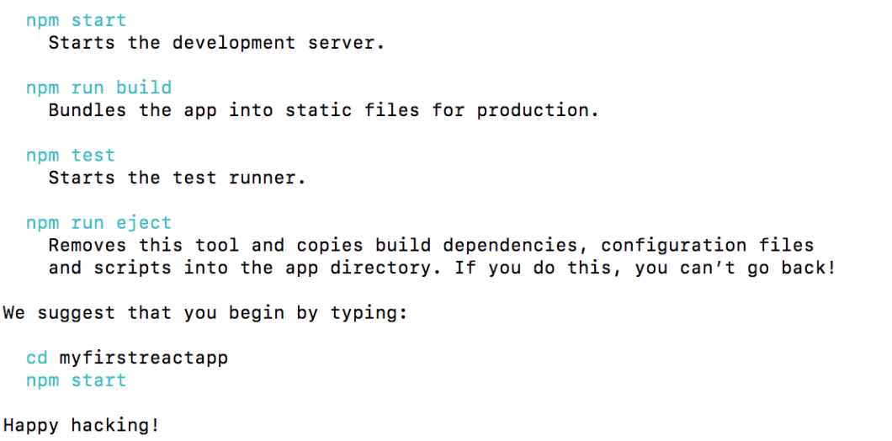

Importing variables from separate js files:

Import { NavBar } from ‘./NavBar.js’;

Note: You need to use “export” on the variable in the location you wish to import from.

SIMPLE WEBPAGE WITH NAVBAR CODE EXAMPLE:

//**********

//NavBar.js

import React from 'react';

export class NavBar extends React.Component {

render() {

const pages = ['home', 'blog', 'pics', 'bio', 'art', 'shop', 'about', 'contact'];

const navLinks = pages.map(page => {

return (

<a href={'/' + page}>

{page}

</a>

)

});

return <nav>{navLinks}</nav>;

}

}

//************

//ProfilePage.js

import React from 'react';

import ReactDOM from 'react-dom';

import { NavBar } from './NavBar.js'

class ProfilePage extends React.Component {

render() {

return (

<div>

<NavBar />

<h1>All About Me!</h1>

<p>I like movies and blah blah blah blah blah</p>

<img src="https://s3.amazonaws.com/codecademy-content/courses/React/react_photo-monkeyselfie.jpg" />

</div>

);

}

}

ReactDOM.render(<ProfilePage />, document.getElementById('app'))

//END

//*************

Passing vars into component using render: (props)

ReactDOM.render(<PropsDisplayer myProp="Hello" />, document.getElementById('app'))

Use it with:

class Greeting extends React.Component {

render() {

return <h1>Hi there, {this.props.myProp}!</h1>;

}

}

Constructor of Component: <Greeting name="Alison", signedIn={false}/>

Example of functions in React:

function talk () {

let speech = '';

for (let i = 0; i < 10000; i++) {

speech += 'blah ';

}

alert(speech);

}

**Note:** within a component:

class Talker extends React.Component {

render() {

return <Button />;

}

talk () {

….

}

}

Default Props in objects, and code that passes them in:

import React from 'react';

import ReactDOM from 'react-dom';

class Button extends React.Component {

display() {

alert("vagycho")

}

render() {

return (

<button onClick={this.display}>

{this.props.text}

</button>

);

}

}

// defaultProps goes here:

Button.defaultProps = { text: "I am a button"}

ReactDOM.render(

<Button text="omer"/>,

document.getElementById('app')

);

//NOTICE: above code passes “omer” into props of the Button class

Code to change states using this.setState({})

class Toggle extends React.Component {

constructor(props){

super(props);

this.state = { color: green };

this.changeColor = this.changeColor.bind(this);

}

changeColor() {

const newColor = this.state.color == green ? yellow : green;

this.setState({ color: newColor });

}

render() {

return (

<div style={{background: this.state.color}}>

<h1>

Change my color

</h1>

<button onClick={this.changeColor}>

Change color

</button>

</div>

);

}

}

ReactDOM.render(<Toggle />, document.getElementById('app'));